EcoRoute AI
Smart Route Optimization System

A PROJECT REPORT SUBMITTED IN PARTIAL FULFILMENT OF REQUIREMENT
FOR THE AWARD OF THE DEGREE

MASTER OF COMPUTER APPLICATIONS (MCA)
OF
MAHATMA GANDHI UNIVERSITY, KOTTAYAM
BY

TENCY TITUS
Reg No: 24PMC157



Marian College Kuttikanam Autonomous
Peermade, Kerala – 685 531
2026
EcoRoute AI
Smart Route Optimization System

A PROJECT REPORT SUBMITTED IN PARTIAL FULFILMENT OF REQUIREMENT
FOR THE AWARD OF THE DEGREE

MASTER OF COMPUTER APPLICATIONS (MCA)
OF
MAHATMA GANDHI UNIVERSITY, KOTTAYAM
BY

TENCY TITUS
Reg No: 24PMC157



Marian College Kuttikanam Autonomous
Peermade, Kerala – 685 531
2026

A Project Report on
EcoRoute AI
Smart Route Optimization System

SUBMITTED IN PARTIAL FULFILMENT OF REQUIREMENT
FOR THE AWARD OF THE DEGREE

MASTER OF COMPUTER APPLICATIONS (MCA)
OF
MAHATMA GANDHI UNIVERSITY, KOTTAYAM
By
TENCY TITUS
Reg No: 24PMC157

Under the guidance of
Ms. Kochumol Abraham
Assistant Professor
PG Department of Computer Applications
Marian College Kuttikkanam Autonomous



Marian College Kuttikanam Autonomous
Peermade, Kerala – 685 531
2026

PG DEPARTMENT OF COMPUTER APPLICATIONS
Marian College Kuttikkanam Autonomous
MAHATMA GANDHI UNIVERSITY, KOTTAYAM
KUTTIKKANAM – 685 531, KERALA.

CERTIFICATE
This is to certify that the project work entitled
EcoRoute AI
is a bonafide record of work done by
TENCY TITUS
Reg. No: 24PMC157
In partial fulfillment of the requirements for the award of Degree of
MASTER OF COMPUTER APPLICATIONS [MCA]
During the academic year 2025-2026

Mr. Win Mathew John
Head of the Department
PG Department of Computer Applications
Marian College Kuttikkanam Autonomous
Ms. Kochumol Abraham
Assistant Professor
PG Department of Computer Applications
Marian College Kuttikkanam Autonomous

External Examiner
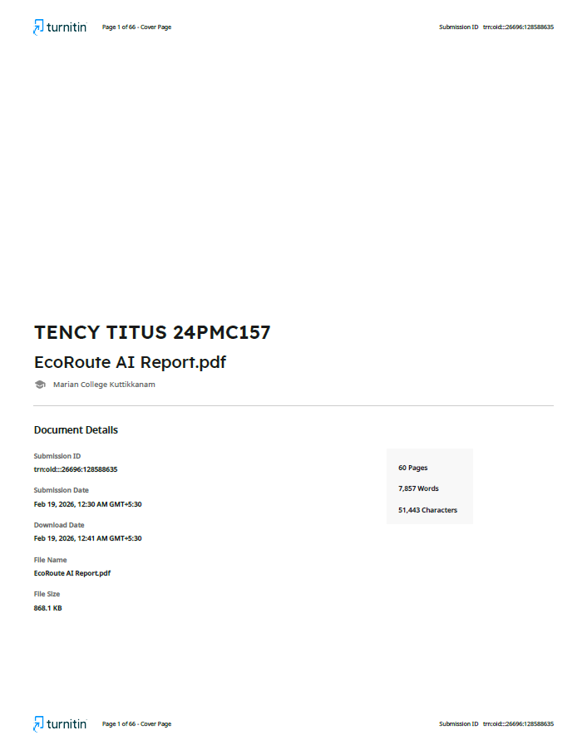

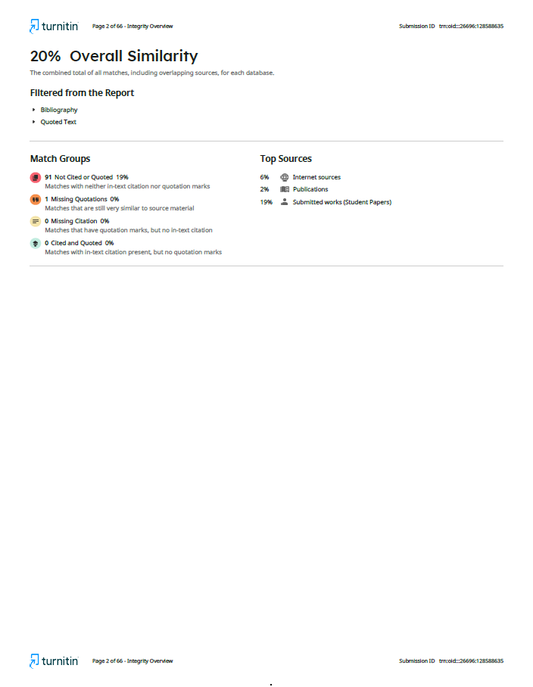

Acknowledgements

I am deeply grateful to the Almighty for granting me the strength and perseverance to successfully complete this project. This report is a testament to the guidance, encouragement, and support I have received from numerous individuals throughout this journey.

I would like to extend my heartfelt gratitude to Mr. Win Mathew John, Head of the Department (MCA), for his invaluable guidance and unwavering support, which have been instrumental in the successful completion of this project.

I am profoundly thankful to my project guide, Ms. Kochumol Abraham, Assistant Professor, PG Department of Computer Applications, Marian College Kuttikkanam, for her insightful guidance and constant encouragement. Her expertise and constructive feedback have been critical in shaping the outcomes of this project.

My sincere thanks also go to the faculty members of the PG Department of Computer Applications for their encouragement and support, which have greatly motivated me during the course of this work.

Finally, I would like to express my gratitude to my peers, friends, and family, whose unwavering support and encouragement have been a source of strength and inspiration. This project would not have been possible without the collective contributions of everyone who stood by me during this academic endeavor.

Tency Titus

ABSTRACT

EcoRoute AI
EcoRoute AI is designed to provide intelligent route optimization and emission prediction for modern transportation and logistics systems. In today’s fast-paced and environmentally conscious world, organizations face challenges in minimizing fuel consumption, reducing operational costs, and lowering carbon emissions while maintaining delivery efficiency. EcoRoute AI addresses these challenges by offering a smart, user-friendly platform where users can manage vehicles, input route details, and generate optimized routes based on multiple performance factors.
The system integrates AI-powered optimization algorithms and emission prediction models to analyze distance, fuel efficiency, load capacity, and environmental impact. It provides data-driven insights that help organizations make cost-effective and sustainable decisions. By balancing operational efficiency with environmental responsibility, EcoRoute AI promotes greener logistics practices.
Additionally, the platform includes secure authentication, performance tracking dashboards, and administrative controls to ensure smooth system management. Overall, EcoRoute AI serves as an intelligent, reliable, and scalable solution for optimizing transportation systems while supporting sustainability goals.

Statement about the Problem:
Many logistics providers and transportation companies struggle to optimize routes efficiently while controlling fuel costs and reducing carbon emissions. Traditional route planning methods often rely on manual decisions or basic navigation tools that do not consider multiple performance factors such as fuel efficiency, load capacity, operational cost, and environmental impact simultaneously.
This lack of intelligent and integrated systems leads to higher fuel consumption, increased operational expenses, inefficient fleet utilization, and greater environmental impact. There is a clear need for a smart, structured, and data-driven platform that simplifies route planning while promoting sustainability and efficiency.

Objective and Scope of the Project:
The primary objective of this project is to develop EcoRoute AI, an intelligent route optimization and emission prediction system that enables organizations to plan efficient, cost-effective, and environmentally sustainable routes.
The scope includes:
- A comprehensive Admin Module for managing user accounts, monitoring system-wide optimization activities, analyzing emission statistics, and overseeing overall platform performance.
- A User Module that allows users to register, manage vehicle details, input route parameters, generate optimized routes, and track emission and fuel consumption data.
- A responsive and intuitive interface that simplifies route planning, enhances user experience, and ensures accurate optimization results.
- An AI-powered optimization engine that analyzes distance, fuel efficiency, load weight, and environmental factors to generate optimal routes.
- An emission prediction module that estimates carbon footprint and provides sustainability insights to support greener transportation decisions.

Methodology:
The EcoRoute AI project is developed using FastAPI (Python) for the backend, React.js for the frontend, and PostgreSQL as the database. The development follows the Agile methodology, ensuring iterative improvements and continuous testing throughout the project lifecycle. The major phases include:
- Requirement Analysis and Planning – Understanding the need for intelligent route optimization, vehicle management, emission prediction, and sustainability tracking.
- Database Design – Designing structured schemas to store user profiles, vehicle details, route data, optimization results, and emission records efficiently.
- API Development – Building RESTful APIs using FastAPI to handle user authentication, vehicle and route management, optimization processing, and analytics retrieval.
- Frontend Integration – Connecting React-based forms, dashboards, and visualization components with backend APIs to enable seamless route input, optimization generation, and performance tracking.
- Testing and Optimization – Ensuring accurate route calculations, reliable emission predictions, system stability, and overall usability through systematic testing and debugging.

Hardware & Software to Be Used:
Hardware:
- A standard computer or laptop with internet connectivity.
Software:
- Backend: FastAPI (Python)
- Frontend: React.js
- Database: PostgreSQL
- Others: Postman for API testing, Git for version control

Testing Technologies Used:
The EcoRoute AI system will undergo comprehensive testing, including:
- Unit Testing – Verifying the correctness of individual modules such as route processing, emission prediction, and user authentication.
- Integration Testing – Ensuring that frontend components, backend APIs, and database operations function seamlessly together.
- User Acceptance Testing (UAT) – Validating usability, optimization accuracy, and emission calculations from the end-user perspective.
- Debugging and Testing Tools – Using Postman for API validation, Pytest for backend testing, and browser developer tools for frontend debugging.

Contribution of the Project:
EcoRoute AI makes a significant contribution by providing a centralized and intelligent platform for route optimization and emission prediction. It streamlines logistics planning by allowing users to manage vehicle data, input route details, and automatically generate optimized routes based on cost, distance, fuel efficiency, and environmental impact. The integration of AI enhances operational decision-making by delivering data-driven optimization results and accurate emission estimates. This helps organizations reduce fuel consumption, lower operational costs, and minimize carbon footprint. Additionally, the system equips administrators with secure tools to monitor user activity, analyze performance metrics, and ensure transparency and efficiency in logistics operations.

Conclusion:
The development of EcoRoute AI results in an efficient, intelligent, and user-friendly platform for sustainable transportation management. It addresses the limitations of manual and basic route planning methods by providing an automated, data-driven optimization solution.
Users can easily generate efficient routes, track emission levels, and analyze performance metrics, while administrators can securely manage system data and monitor overall platform performance. With its intuitive interface, AI-powered optimization engine, and reliable system architecture, EcoRoute AI promotes operational efficiency, environmental responsibility, and smarter logistics planning.

TABLE OF CONTENTS

Chapter |  |  |  | Page No
1 |  | Introduction |  | 1
 |  | 1.1 | Problem Statements | 2
 |  | 1.2 | Proposed System | 2
 |  | 1.3 | Features of the Proposed System | 2
2 |  | Functional Requirements |  | 4
3 |  | Non-functional Requirements |  | 7
4 |  | UML Diagrams |  | 10
 |  | 4.1 | Use Cases | 11
 |  | 4.2 | Use Case Diagram | 15
 |  | 4.3 | Activity Diagram | 16
 |  | 4.4 | Class Diagram | 19
5 |  | Test Cases |  | 20
 |  | 5.1 | Login Page | 21
 |  | 5.2 | Registration Page | 21
 |  | 5.3 | Income and Deduction Management page | 22
6 |  | Input Design and Output Design |  | 23
7 |  | System Implementation |  | 28
8 |  | AI Integration |  | 41
9 |  | Future Enhancements |  | 44
10 |  | Conclusion |  | 47
Annexure |  |  |  | 49
A | Screen Shots |  |  | 50
B | Ethical Clearance Form |  |  | 53

TABLE INDEX

Table Page No

5.1 Test Case for Login 21

5.2 Test Case for Registration 21

5.3 Test Case for Vehicle and Route Management 22

7.1 User Registration table database design 32

7.2 Vehicles database design 33

7.3 Routes table database design 33

7.4 OptimizationResults table database design 34

7.5 EmissionRecords table database design 34

FIGURE INDEX

Figure Page No

4.1 Use Case Diagram 15

4.2 Activity Diagram – User 16

4.3 Activity Diagram – Logistic Manager 17

4.4 Activity Diagram – Admin 18

4.5 Class Diagram 19

